ASSIGNMENT 1

Name: kandlagunta Lakshmi Mrudhula
Batch:G15 Pyhton

Question 1

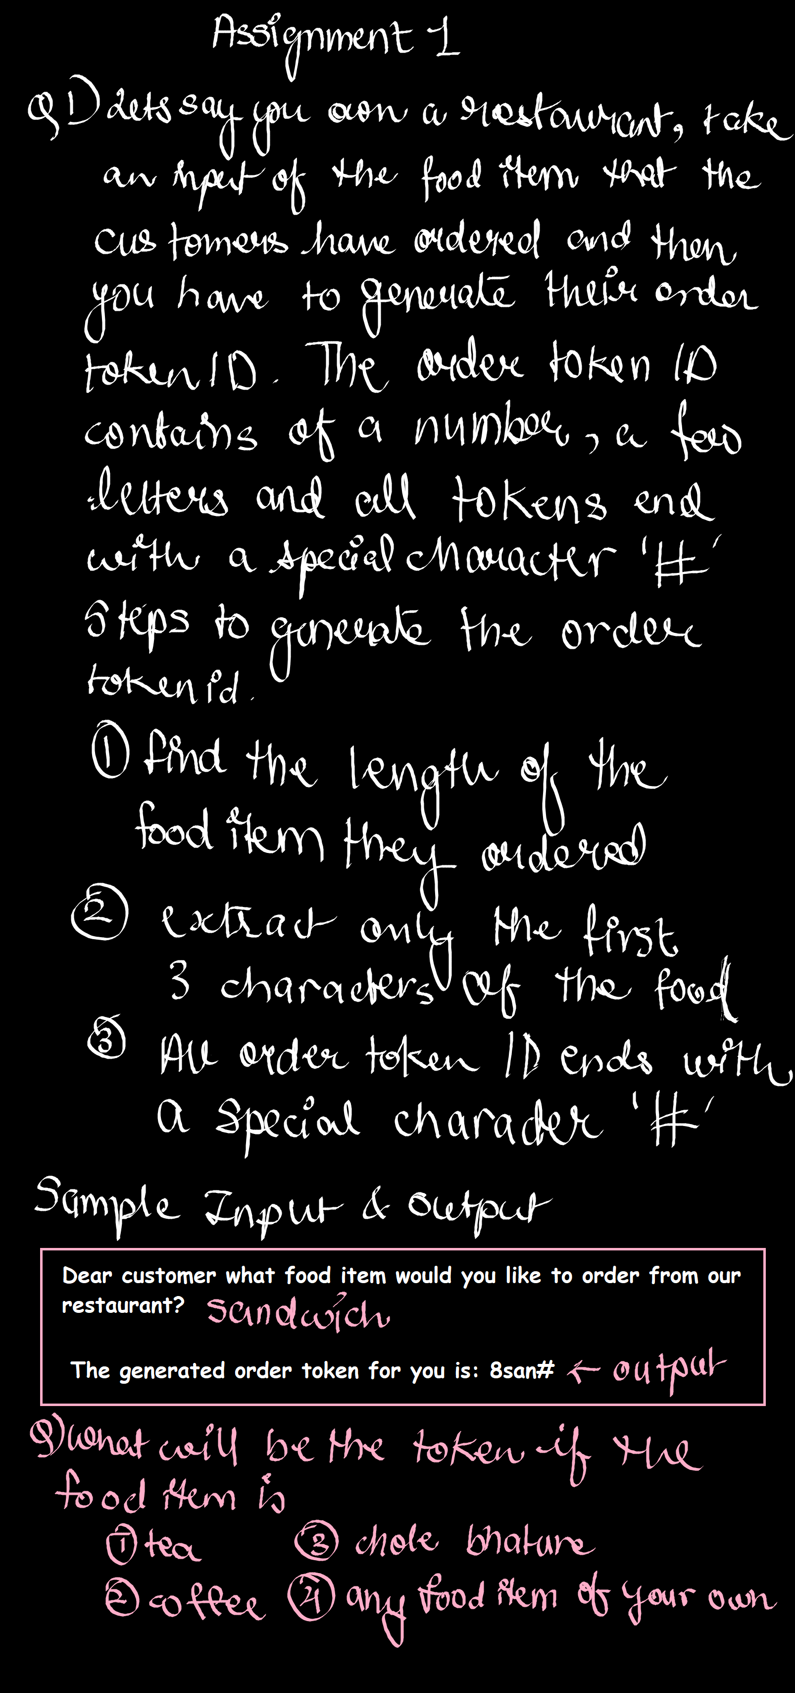
Code:
item=input("Dear costumer what food item would u like to order from our restaurent: ")
l=len(item)
a=item[:3]
b="#"
id=str(l)+a+b
print("The generated order token for u is:",id)

Sample Input and Output:

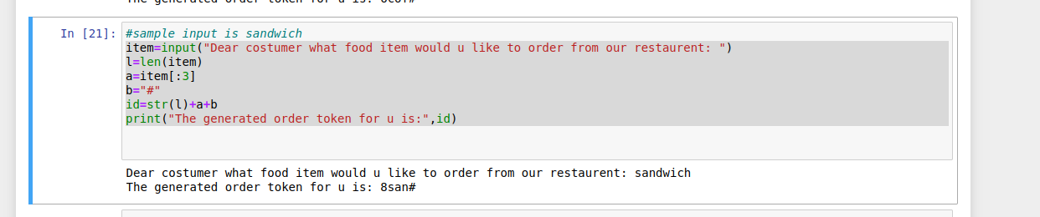

Other Outputs:

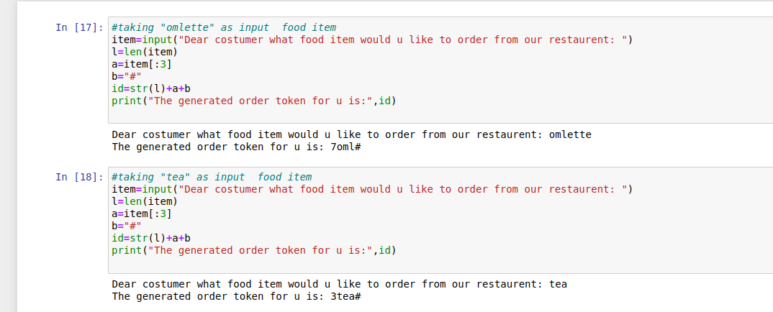
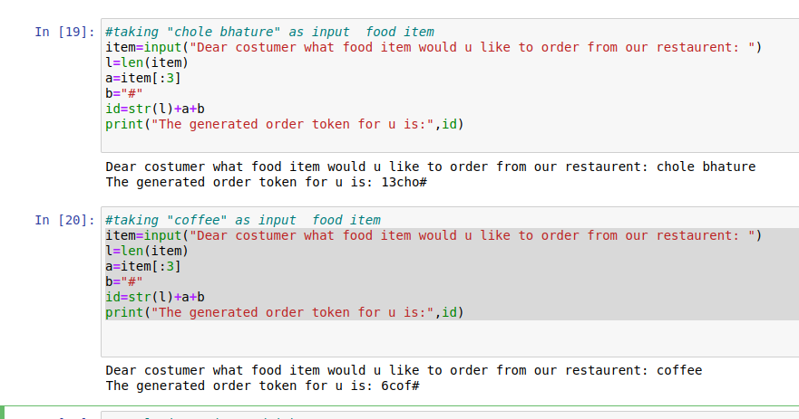

Question 2

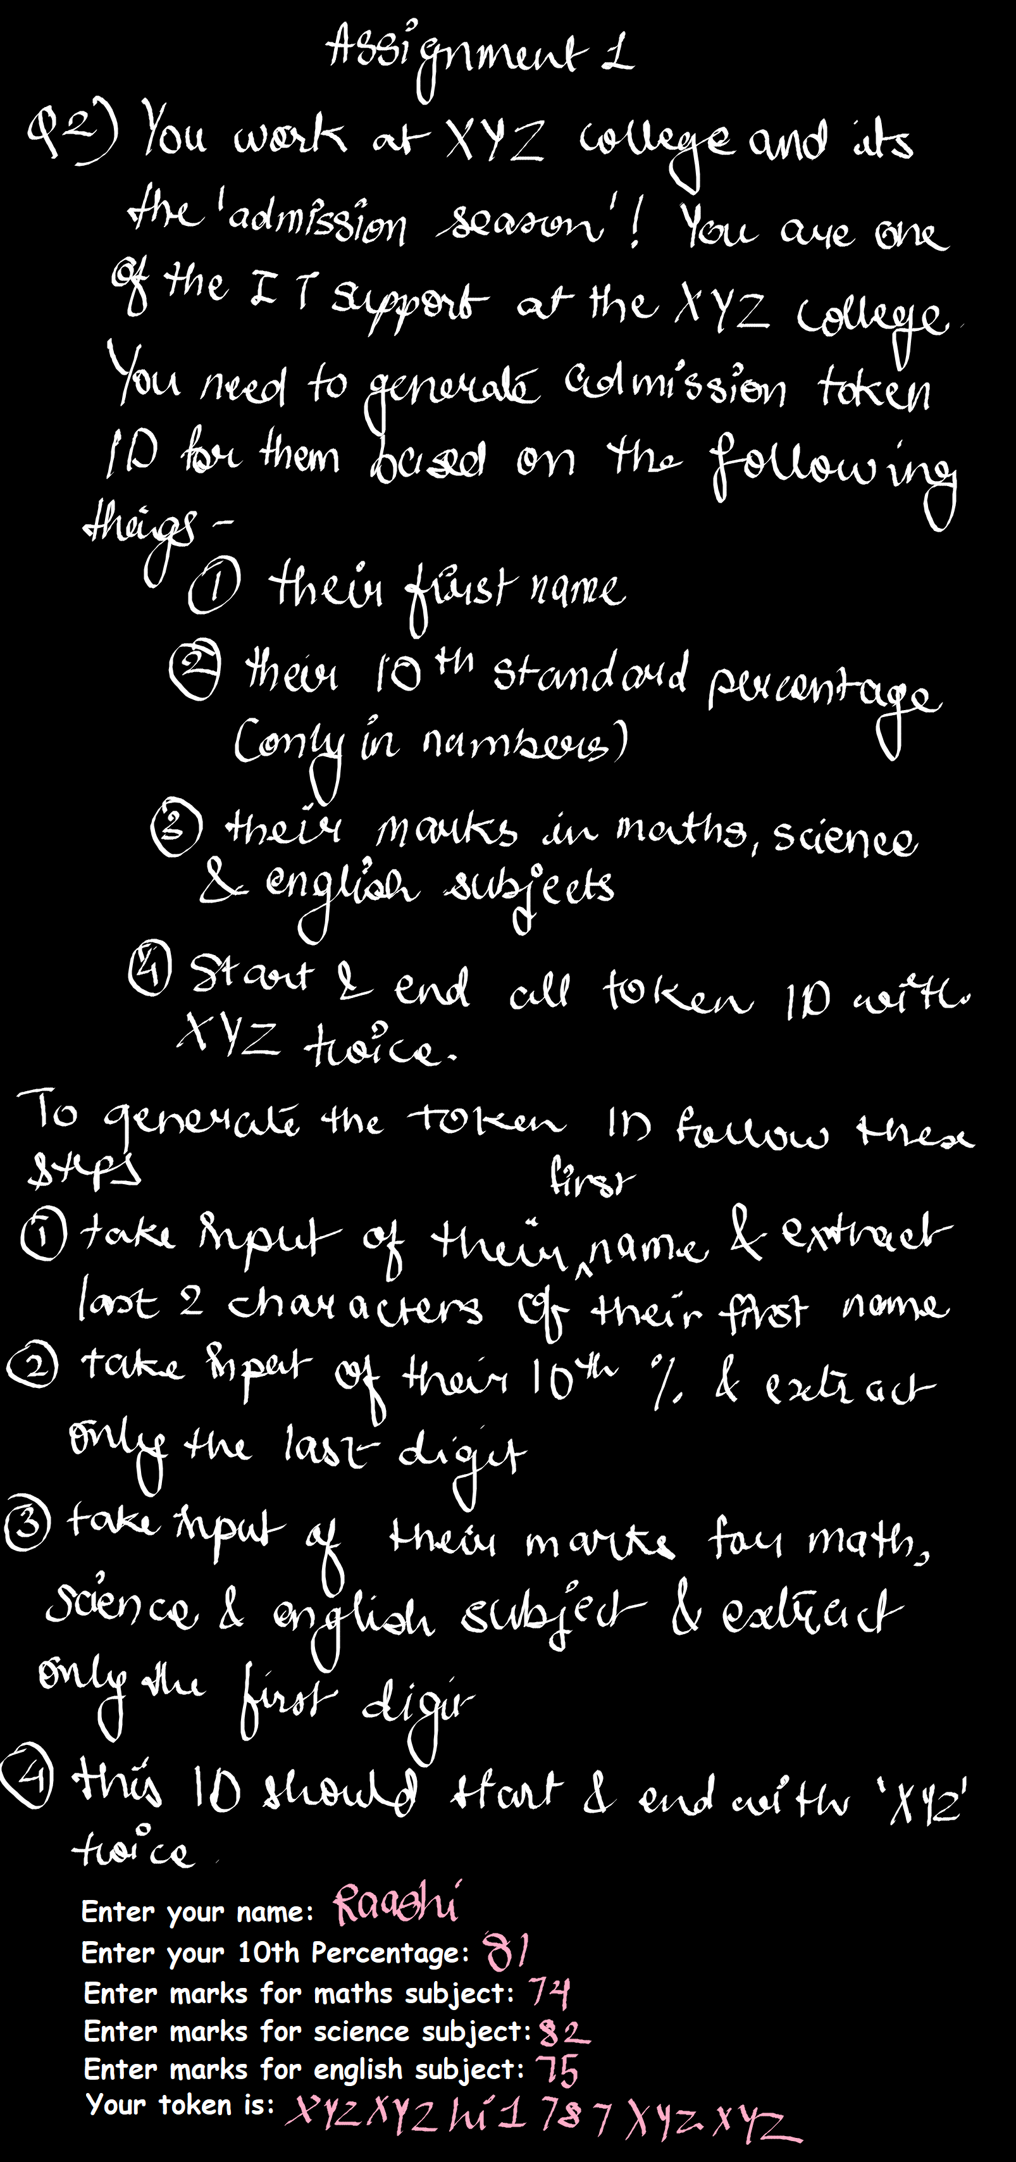
Code

name=input("enter the name:")
a=name[-2:]
per=input("enter your 10th percentage:")
b=per[-1]
mat=input("enter marks for maths subject:")
c=mat[0]
sci=input("enter marks for science subject:")
d=sci[0]
eng=input("enter marks for english subject:")
e=eng[0]
college="XYZ"
token=college+college+a+str(b)+str(c)+str(d)+str(e)+college+college
print("your token is:",token)

Output:
